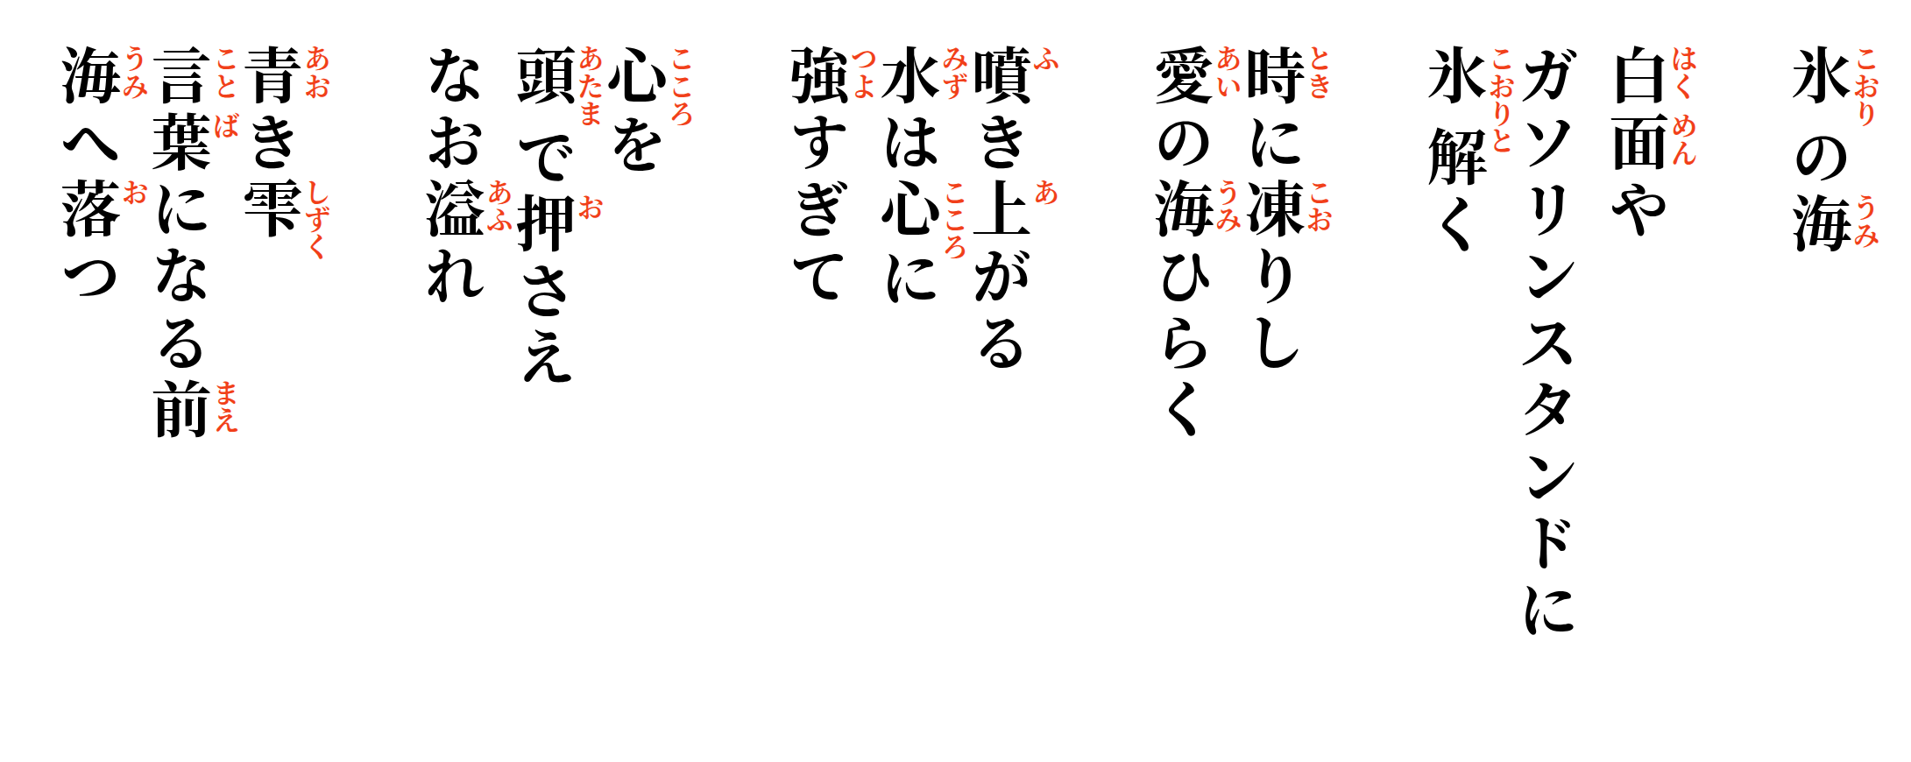
The Ocean Beneath the Ice - 氷の海

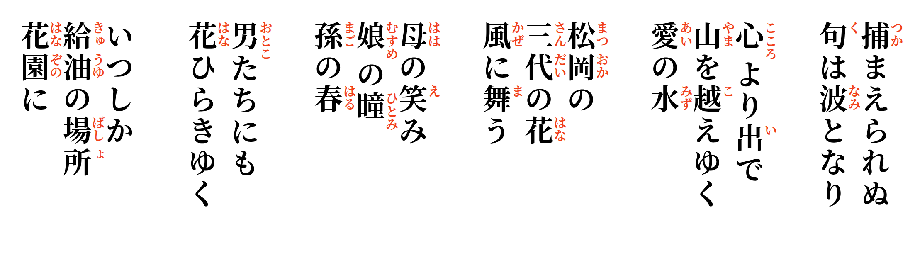
Blue drops,
before becoming words,
fall back into the sea.
The mind tries
to hold the heart down,
yet still it overflows.
Water erupts upward—
too powerful for the heart to contain.
Frozen in time,
the ocean of love
opens.
White mask—
at the gas station
the ice begins to melt.

Before we know it,
the place of filling tanks has become a garden.
Poems that cannot be caught
become waves.
Flowing from the heart,
the waters of love
cross the mountains.
At Matsuoka,
three generations of flowers
dance upon the wind.
A mother's smile,
a daughter's eyes,
a granddaughter's spring.
And even among the men,
flowers begin to open.

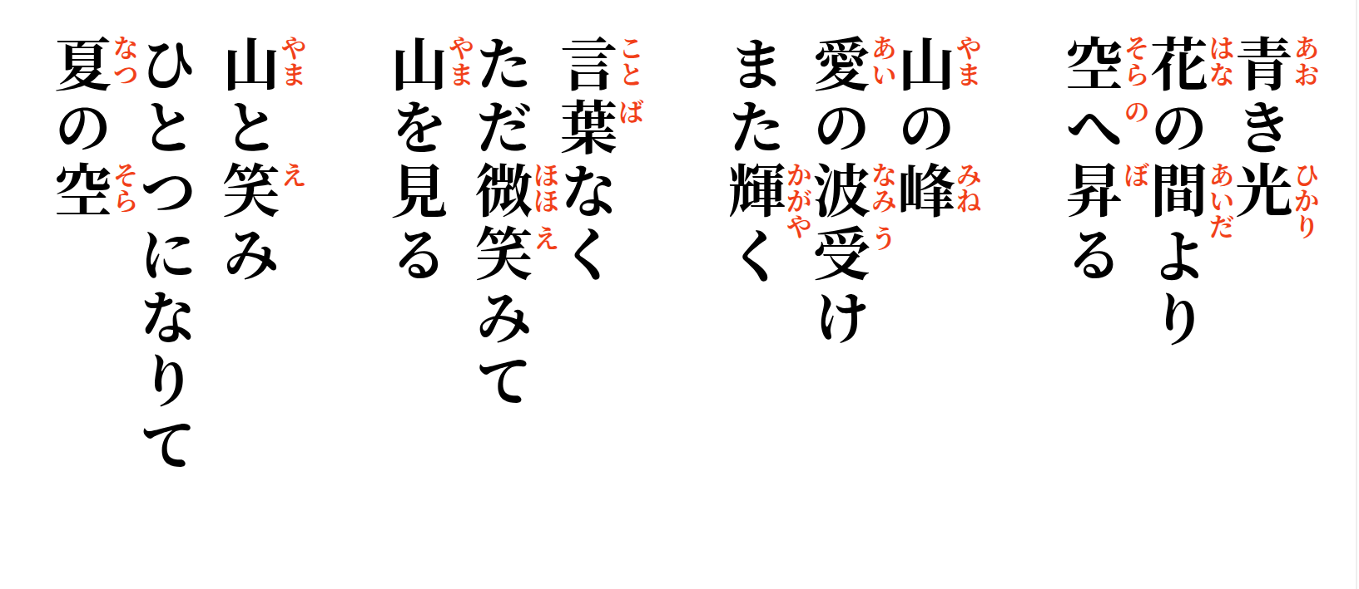

Blue light rises
between the flowers
toward the sky.
The mountain peaks,
receiving the waves of love, shine once again.
Without a word, only a smile,
looking toward the mountain.
Mountain and smile
become one beneath
the summer sky.

